**Linux Server Course System Configuration and Operation**

Index

**Chapter:1 - Explain Linux Kernel and Boot Concepts**

[Tutorial](https://www.youtube.com/watch?v=WMy3OzvBWc0&t=30s)

1. What is BIOS and UEFI? [Deferances](https://www.freecodecamp.org/news/uefi-vs-bios/) .



* 1. BIOS (basic input/output system) is the program a computer's microprocessor uses to start the computer system after it is powered on. It also manages data flow between the computer's operating system (OS) and attached devices, such as the hard disk, video adapter, keyboard, mouse and printer.
  2. UEFI stands for Unified Extensible Firmware Interface. It does the same job as a BIOS, but with one basic difference: it stores all data about initialization and startup in an .efi file, instead of storing it on the firmware. all modern computers come equipped with UEFI by default.
  3. [Deferances](https://www.freecodecamp.org/news/uefi-vs-bios/) .

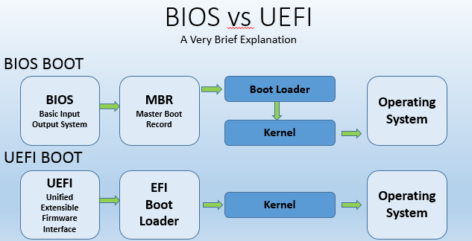

1. What is GRUB in Linux? GRUB vs GRUB2.
   1. GRUB is a complete program for loading and managing the boot process. It is the most common bootloader for Linux distributions. A bootloader is the first software that runs when a computer starts. It loads the kernel of the operating system and then the kernel initializes the rest of the operating system: shell, display manager, desktop environment, etc.



* 1. GRUB vs GRUB2.

Check GRUB or GRUB2 using terminal

cat /etc/default/grub

This is a configuration file we can change it. After changing we need to run

sudo update-grub

Check those files (grub.cfg, menu.lst)

cd /boot/grub

ls

1. Boot Methods



* 1. [What is PXE?](https://www.manageengine.com/products/os-deployer/pxe-preboot-execution-environment.html)

Preboot Execution Environment(PXE) is a client-server interface that allows computers in a network to be booted from the server before deploying the obtained PC image in local and remote offices, for PXE enabled clients. PXE network boot is performed using client-server protocols like DHCP(Dynamic Host Configuration Protocol) and TFTP(Trivial File Transfer Protocol). PXE will be enabled by default on all computers.

* 1. [What is iPXE?](https://ipxe.org/)

iPXE is the leading open source network boot firmware. It provides a full PXE implementation enhanced with additional features such as:



* 1. [Boot process.](https://www.freecodecamp.org/news/the-linux-booting-process-6-steps-described-in-detail/)

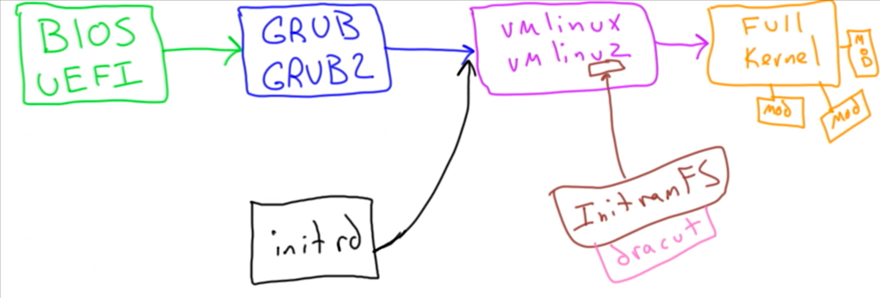

See all linux main files (kernel files, system map, kernel config files)

cd /boot

ls

See the name of actual running kernel (all different modules)

cd /lib/modules

ls

ls *